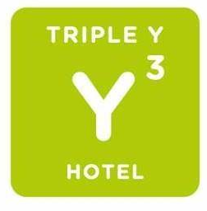
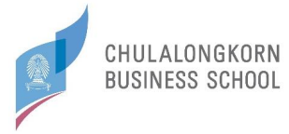
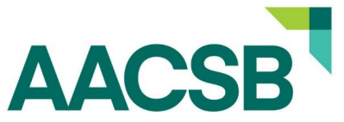

Event Date
Assurance of Learning Seminar I 14 – 15 November 2022
Asia Pacific Annual Conference 16 – 18 November 2022

Attention to: Benjamaporn Sila (Ms.), Sales Manager
948 Rama IV Road, Wang Mai, Pathumwan, Bangkok, 10330, Thailand
Phone: (+66) 2 219 1611 Ext. 129 Fax: (+66) 2 219 1612
Email: Benjamaporn.s@tripleyhotel.com
www.tripleyhotel.com

Room Rate: Room Type Breakfast
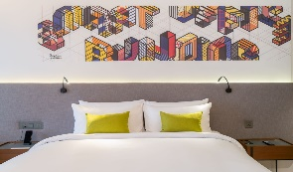
☐ Deluxe King Room (34 m²) ☐ Not included: 2,450 THB/Night ___Room (s), ___Guest (s) ☐ Included: 2,900 THB/Night ___Room (s), ___Guest (s)
*Breakfast at Coffee Club or Tim Hortons

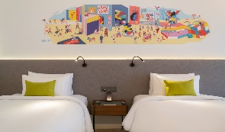
☐ Deluxe Twin Room (34 m²) ☐ Not included: 2,450 THB/Night ___Room (s), ___Guest (s) ☐ Included: 2,900 THB/Night ___Room (s), ___Guest (s)
*Breakfast at Coffee Club or Tim Hortons

Date: | Arrival: | Departure:
 | No. of night(s):

Personal  Information: | First Name:
 | Family Name:
 | Organization:
 | Address:
 | City: Country:
 | Phone: Fax:
 | Email:

- - Please return the completed reservation form to Benjamaporn.s@tripleyhotel.com - -

